**Assignment 1**

--assignment 1

CREATE DATABASE Northwind;

--create table

create table Products(

ProductID int not null,

ProductName varchar(40) not null,

SupplierID int not null,

CategoryID int not null,

QuantityPerUnit varchar(20) not null,

UnitPrice Decimal(10,4) not null,

UnitsInStock int not null,

UnitsOnOrder int not null,

ReorderLevel int not null,

Discontinued bit

)

--data insert

insert into Products values

(1, 'Chai', 1, 1, '10 boxes - 20 bags', 18.0000, 39, 0, 10, 0),

(2, 'Chang', 1, 1, '24 - 12 oz bottles', 19.0000, 17, 40, 25, 0),

(3, 'Aniseed Syrup', 1, 2, '12 - 550 ml bottles', 10.0000, 13, 70, 25, 0),

(4, 'Chef Antons Cajun Seasoning', 2, 2, '48 - 6 oz jars', 22.0000, 53, 0, 0, 0),

(5, 'Chef Antons Gumbo Mix', 2, 2, '36 boxes', 21.3500, 0, 0, 0, 1),

(6, 'Grandmas Boysenberry Spread', 3, 2, '12 - 8 oz jars', 25.0000, 120, 0, 25, 1),

(7, 'Uncle Bobs Organic Dried Pears', 3, 7, '12 - 1 lb pkgs', 30.0000, 15, 0, 10, 0),

(8, 'Northwoods Cranberry Sauce', 3, 2, '12 - 12 oz jars', 40.0000, 6, 0, 0, 0),

(9, 'Mishi Kobe Niku', 4, 6, '18 - 500 g pkgs', 97.0000, 29, 0, 0, 0),

(10, 'Ikura', 4, 8, '12 - 200 ml jars', 31.0000, 31, 0, 0, 0),

(11, 'Queso Cabrales', 5, 4, '1 kg pkg', 21.0000, 22, 30, 30, 0),

(12, 'Queso Manchego La Pastora', 5, 4, '10 - 500 g pkgs', 38.0000, 86, 0, 0, 1),

(13, 'Konbu', 6, 8, '2 kg box', 6.0000, 24, 0, 5, 0),

(14, 'Tofu', 6, 7, '40 - 100 g pkgs', 23.2500, 35, 0, 0, 0),

(15, 'Genen Shouyu', 6, 2, '24 - 250 ml bottles', 15.5000, 39, 0, 5, 0);

select * from Products;

1. --1st Write a query to get a Product list (id, name, unit price) where current products cost less than $20.

SELECT ProductID,ProductName,UnitPrice

FROM Products

WHERE ((UnitPrice < 20) AND (Discontinued = 0));

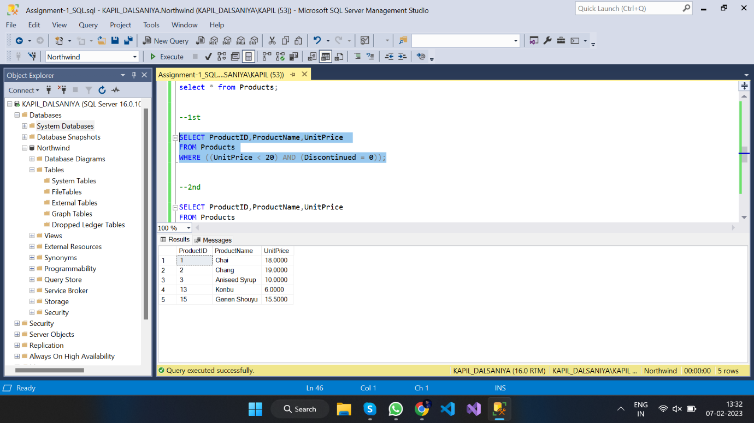

1. --2nd Write a query to get Product list (id, name, unit price) where products cost between $15 and $25

SELECT ProductID,ProductName,UnitPrice

FROM Products

WHERE ((UnitPrice < 25) AND (UnitPrice > 15));

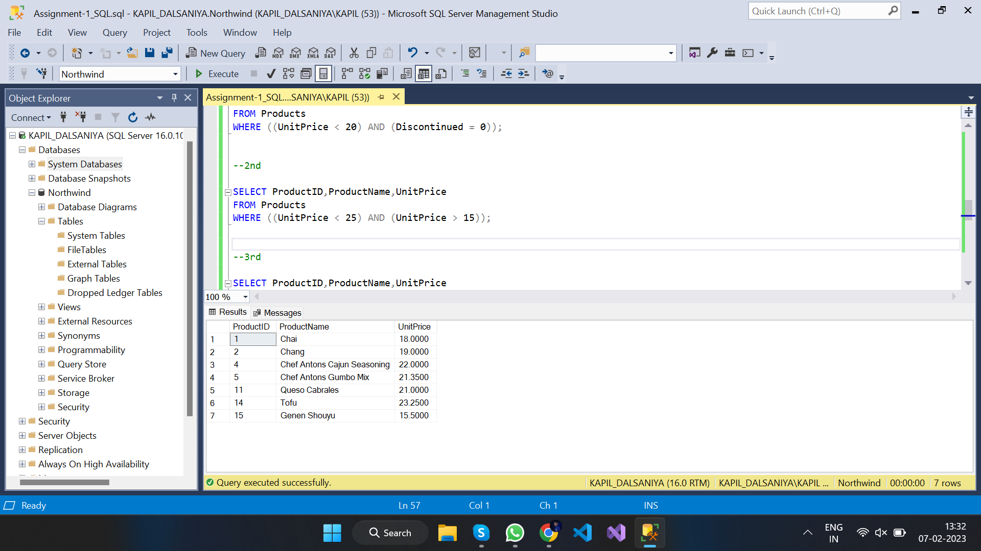

1. --3rd Write a query to get Product list (name, unit price) of above average price.

SELECT ProductID,ProductName,UnitPrice

FROM Products

WHERE UnitPrice > (SELECT avg(UnitPrice) FROM Products);

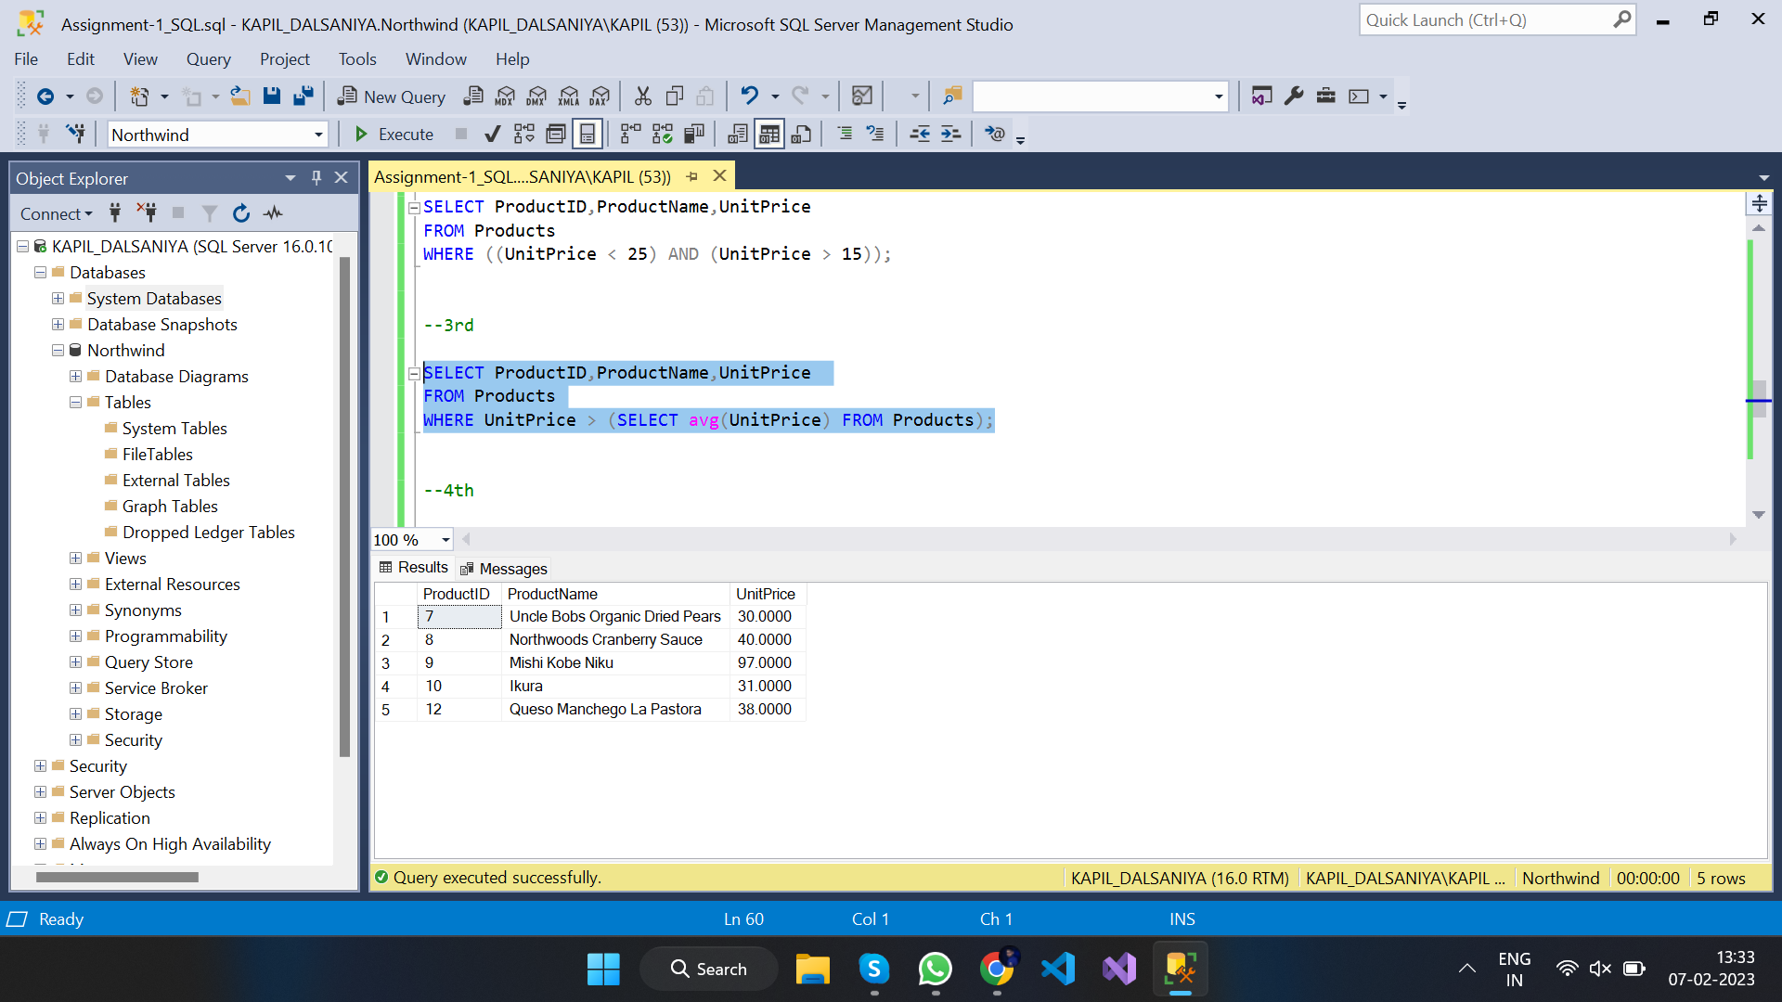

1. --4th Write a query to get Product list (name, unit price) of ten most expensive products

SELECT DISTINCT ProductName, UnitPrice

FROM Products AS a

WHERE 10 >= (SELECT COUNT(UnitPrice) FROM Products AS b WHERE b.UnitPrice >= a.UnitPrice);

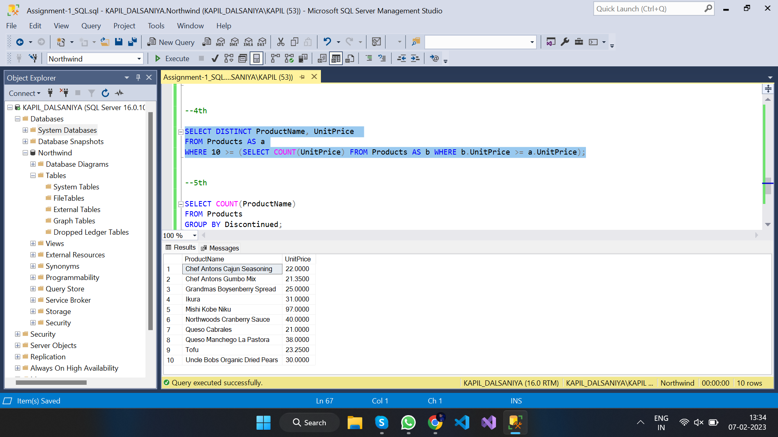

1. --5th Write a query to count current and discontinued products

SELECT COUNT(ProductName)

FROM Products

GROUP BY Discontinued;

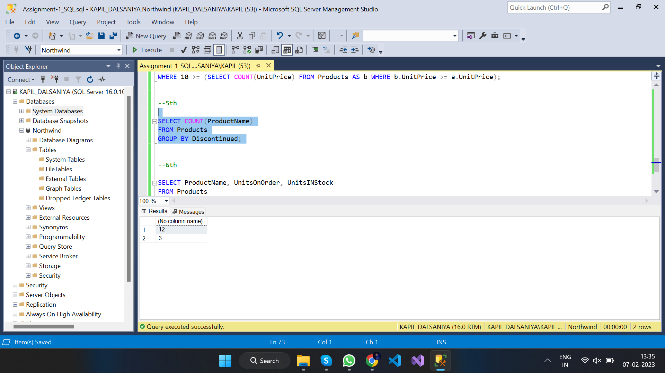

1. --6th Write a query to get Product list (name, units on order , units in stock) of stock is less than the quantity on order

SELECT ProductName, UnitsOnOrder, UnitsINStock

FROM Products

WHERE ((UnitsInStock < UnitsOnOrder) AND (Discontinued = 0));

